**MIE1623 Final Project - Surgical Scheduling**

Members:

Linda Hao 1003056541

Pai Peng 1002725394

Liyan Liu 1002896100

Qiaoyi Yan 1003130774

**Table of Contents**

**Executive Summary** **2**

**Background** **3**

**Problem Description & Assumption** **3**

**Data Overview** **3**

Hospitals 3

Patients 3

Cost 4

Initial analysis 4

**Model Description** **4**

Approach 5

Step One Model 5

Step Two Model 6

**Results** **7**

**Results Analysis** **7**

Patients Cancellation 7

Overtime in OR 8

**Possibility for collaboration** **8**

The Extra Step model 8

Model Result 9

**Conclusion** **10**

**Appendix** **11**

# Executive Summary

This report is designed to analyze the scheduling problems of the three hospitals within the Outer Planet region (OP) of the local health integration networks (LHIN) in Ontario - Serenity , Firefly, and Hands of Blue Hospital. Currently all three hospitals are routinely experiencing some of the highest rates of surgical cancellation and overtime in the province, and there is also a lack of communication between the hospitals.

Using the given hospital capacity, patient operating time and overall cost data, the team is able to solve the problem by dividing the large problem into smaller pieces. We approached the problem by firstly solving for the weekday that each patient should be assigned to, then distributing the patient on each day of the week given the number of ORs. Using OpenSolver in excel, the team is able to obtain a schedule quickly that accommodates all 132 patients for surgical operations with minimized cost. Further analysis is also drawn from the results including the evaluation of the cost, as well as the choices of overtime in the ORs.

The team also explored the possibility of collaboration, which allows hospitals to transfer their patients to other hospitals for quicker operations. An additional step of assigning patients to a hospital is added to our model, and an updated schedule was obtained by the new models. Comparisons are also drawn on the cost, number of OR opened and total overtime between the collaborative and non-collaboration schedule, and the team recommends the collaboration since it drastically reduces the overtime in hospital staff.

# Background

The problem is based on the local health integration networks (LHINs) in Ontario, which consist of 14 regions that cover the entire Ontario and are responsible for health system planning, system funding, and home and community care support. We assume a fictional LHIN region Outer Planets (OP) that consists of three hospitals - Serenity Hospital, Firefly Hospital, and Hands of Blue Hospital. Each hospital currently operates separately from the others, which means they have their own patients and each patient will only be operated on in the OR room of their assigned hospital. However, LHIN has found that all three hospitals in the OP region routinely experience the highest rate of surgical overtime and cancellation across the province. They suspect the main reason behind their low efficiency was because of their outdated surgical schedules, as well as a lack of collaboration and resource sharing between the three hospitals.

The team has been tasked to redevelop a set of surgical schedules for all three hospitals that improve their surgical operation efficiencies and allows for collaborative patient scheduling. The new schedules will allow any patients to be operated on (including the ones already assigned to a hospital) at any of the three hospitals, and the OP LHIN is interested in the potential efficiency gains brought by this collaboration.

# Problem Description & Assumption

The team will need to develop a schedule that ideally allows the patients from all three hospitals to be operated on in a timely manner, with potentially no cancellation and minimized overtime. However, since surgical inefficiency is an ongoing urgent issue and a solution is needed quickly, LHIN prioritizes the feasibility and practical value of the solution over its optimality.

The team assumes that each hospital in the OP LHIN region has enough surgeons, nurses, and equipment to perform any scheduled surgeries in the entire LHIN. The regular OR room hours are 7 hours from Monday to Friday. All surgeons and nurses in the LHIN will have a maximum of 12-hours shift on any day, therefore the maximum overtime per surgeon/nurse per day will be 5 hours after subtracting the regular 7-hour OR opening time.

# Data Overview

## Hospitals

Surgical operations will only be done in the OR room for each hospital. There are 5 OR rooms available at the Serenity Hospital, 4 at the Firefly Hospital, and 3 at the Hands of Blue Hospital.

## Patients

The patient datasheet contains the information of all patients that are currently being assigned to each hospital for operations. Each patient is identified by a unique patient ID, their total required OR time in minutes, as well as their current health status measured from 1~5, with the higher value indicating worse health. There are a total of 132 patients. Serenity Hospital currently has 59 patients scheduled for OR, and Firefly Hospital has 44 patients, while Hand of Blue Hospital has 29 patients, with each patient having varying required OR time and health conditions.

## Cost

The major costs are associated with opening and running OR rooms at each hospital, as well as cancellation and overtime as shown below in figure 3.1.

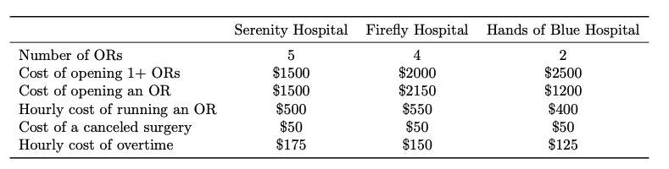

*Figure 3.1. Cost breakdown*

As we can see from the figure, there’s a fixed cost of running ORs at each hospital, meaning that the cost will not be affected by the number of OR rooms opened as long as there is at least one OR room open at the hospital. There is also a variable opening cost and hourly running cost associated with opening and running one OR. One surgery cancellation will cost each hospital differently, and the staff overtime will also be billed on an hourly basis for each hospital.

## Initial analysis

Based on the volume of patients, patient OR time, and OR availability at each hospital, the team was able to regroup the above data in table 3.1 below.

|  | **Serenity Hospital** | **Firefly Hospital** | **Hands of Blue Hospital** |
| --- | --- | --- | --- |
| **Total Patient OR time** | 129 hrs | 100 hrs | 61 hrs |
| **Minimum Number of OR required** | 3 | 2 | 2 |

*Table 3.1 Initial Data Analysis*

The team anticipates the Serenity Hospital to open the most ORs because of its high patient volume, while Firefly and Hands of Blue Hospital both need to have at least 2 OR open during the week to satisfy the demands. The minimum number of OR required is determined on the maximum possible 12-hour shifts/day for each OR.

# 

# 

# Model Description

## Approach

As stated in the problem description, the main goal it’s for the team to achieve a scheduling solution that is feasible, quick to obtain, and practiced among all three hospitals, and that the optimality of the solution is not our top concern.

Given the size of the problem, the team expects one obstacle while obtaining the solution to be the dimension of solutional space and the computational complexity of our model. Taking Serenity Hospital, the hospital with the largest patient volume, for example, we anticipate having 59 patients * 5 OR rooms * 5 weekdays = 1475 decision variables to determine the exact date and OR for all of its 59 patients. In addition, the patient’s current health condition and the collaboration effort will also need to be considered, which adds to the model complexity and computation times.

The team, therefore, adopted the divide-and-conquer strategy to break down the problem into smaller pieces and solve for answers one by one. Firstly, we will focus on finding the weekday that each patient will be operated on for each hospital. Secondly, we can move on to determine the OR room for each patient given their assigned hospital from the previous solution. Looking at Serenity Hospital again, we have successfully reduced the number of variables to 472 decision variables combined, which will greatly shorten the computation time of our model.

## Step One Model

***Set:***

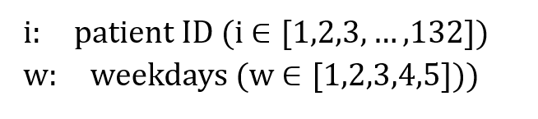

***Parameters:***

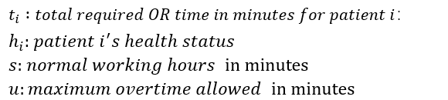

***Variable:***



***Objective function and constraints:***

The objective is to assign all patients while still maintaining low overtime, the team chooses to minimize the summation of overtime in all operating rooms across the week (Monday to Friday). The objective function will be subjective to the following constraints:

1. Decision variables take integer value only.
2. Each patient is assigned once and once only.
3. Overtime upper limit is respected.

The **mathematical model** is as follows:

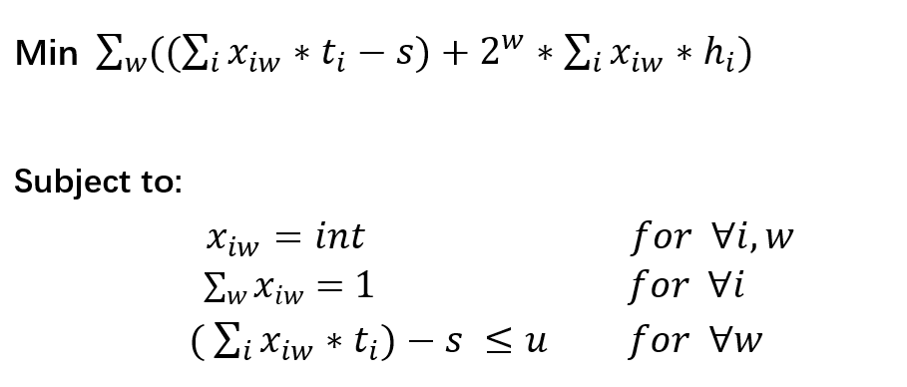

## Step Two Model

For each hospital scheduling on each working day, the team has an individual model to tune the minimized cost. The single model is shown below:

***Set:***



***Parameters:***

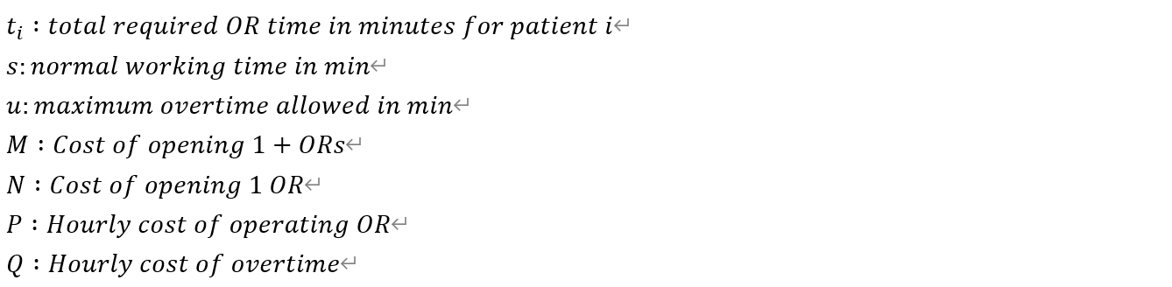

***Variable:***



***Objective function and constraints:***

In this step, the objective is to minimize the cost by distributing the patients

according to each day of the week following the result of step 1. For a single

hospital, each weekly day with a given number of OR opened is set to be one trial

model. The objective function will be subjective to the following constraints:

1) Every patient is scheduled at least once, which will be reinforced by the minimization process to make it strictly once.

2) Overtime should be non-negative. Notice that this constraint is not mandatory as the solver has already incorporated the option of keeping all variables positive and it will output an optimal schedule(not unique) with or without it. But the problem is, without this constraint, the solver finds the optimal solution in a way that tends to fill up the space of a few days wholly while leaving other days idle (in terms of the overtime session). We incorporate this constraint anyway since we thought it would be more human to evenly distribute the workload each day.

3) Overtime does not exceed 5 hours(or say it ends at 20:00). This constraint is added to reflect how ORs normally won’t be operating after evening. Although there isn’t a general standard as to when exactly they close, we carefully choose the time 20:00/8 PM based on the knowledge that OR nurses tend to take a 12-hours shift that starts at 7 AM and ends at 8 PM. The overtime limit for step 2 is 1 hour larger than step 1 since the hours are rounded up each day for calculating the cost.

4) Decision variables X takes non-negative values.

The **mathematical model** is as follows:

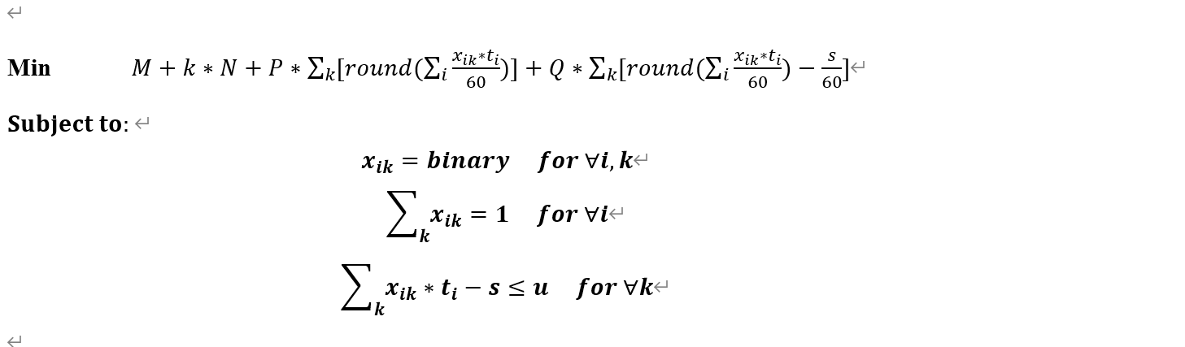

# Results

The following working hour distribution is obtained based on optimization results from our 2-steps model:

| **Hospital** | **Serenity** | **Firefly** | **Hands of Blue** | **Sum** |
| --- | --- | --- | --- | --- |
| **Amount of Patient** | 59 | 44 | 29 | 132 |
| **Number of OR Opened** | 3 | 2 | 2 | 7 |
| **Weekly Cost** | $99750 | $94650 | $42525 | $236925 |
| **Weekly OR Overtime /hrs** | 50 | 25 | 21 | 96 |

*Table 5.1 Final working hour distribution in ORs*

Please refer to the excel spreadsheet for a more detailed calculation process and results. The Appendix A shows the visualization of the proposed schedules for all three hospitals.

# Results Analysis

## Patients Cancellation

According to Table 4.1, all of the patients were able to be scheduled for operations during the week, therefore there is no patient cancellation in our model. This is because the team listed in the constraint that every patient should be scheduled, and the plenty of overtime available also made it possible.

## Overtime in OR

According to table 6.1, the overtime varies in each hospital and in each day during the week. Overall Serenity Hospital has a total overtime of 50 hrs, while Firefly and Hands of Blue Hospital both have an overtime of 21 hrs in a week.

|  | **Mon** | **Tues** | **Wed** | **Thurs** | **Fri** | **Sum** |
| --- | --- | --- | --- | --- | --- | --- |
| Overtime in Serenity Hospital(hrs) | 13 | 12 | 13 | 12 | 0 | **50** |
| Overtime in Firefly Hospital(hrs) | 3 | 5 | 5 | 5 | 3 | **21** |
| Overtime in Hands of Blue Hospital(hrs) | 8 | 7 | 6 | 0 | 0 | **21** |

*Table 6.1 Rounded-up Overtime in each hospital*

# Possibility for collaboration

To collaborate, we would essentially need an extra step for allocating patients to hospitals. We did the following investigation to compare cost efficiency:

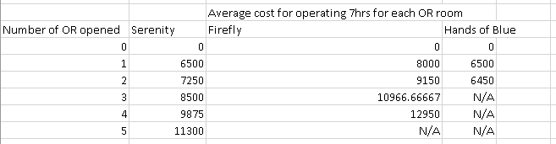

*Table 7.1 Average OR cost at each hospital*

It is obvious that Hands of Blue is the most efficient, followed by Serenity and then Firefly. We adopted this and made a greedy algorithm to fill up the space available in Hands of Blue first, then the Serenity Hospital and lastly the Firefly hospital. Model in the following session.

## The Extra Step model

***Set:***

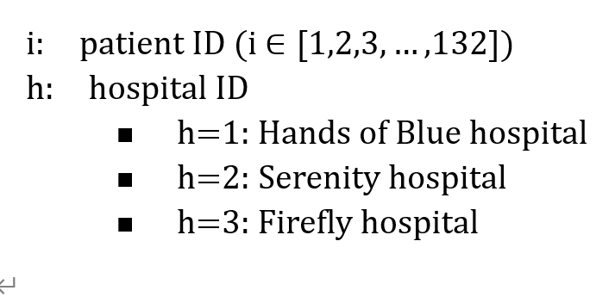

***Parameters:***

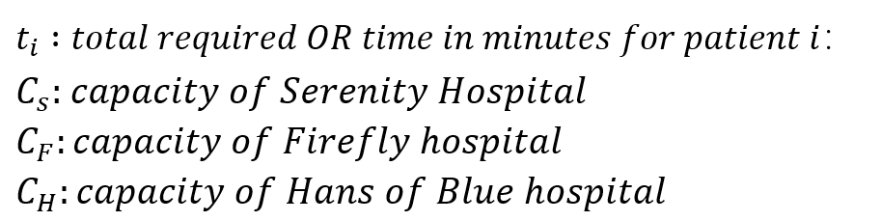

***Variable:***



***Objective function and constraints:***

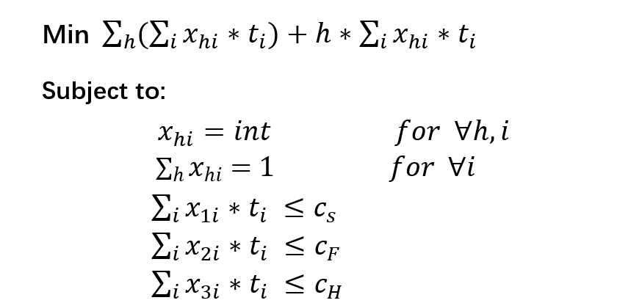

## 

## Model Result

The following working hour distribution is obtained based on optimization results from our collaboration model:

| **Hospital** | **Serenity** | **Firefly** | **Hands of Blue** | **New Sum** | **Old Sum from non-collab model** |
| --- | --- | --- | --- | --- | --- |
| **Amount of Patient** | 81 | 17 | 34 | 132 | 132 |
| **Number of OR Opened** | 5 | 2 | 2 | 9 | 7 |
| **Weekly Cost** | $129450 | $44250 | $54200 | $227900 | $234125 |
| **Weekly OR Overtime /hrs** | 14 | 4 | 4 | 22 | 92 |

*Table 7.2 Final working hour distribution in three hospitals after collaboration*

As a result of collaboration, the Serenity Hospital ended up taking more patients from the other two hospitals, leading to an increased number of OR. However, we were able to reduce the overtime drastically, which balances the increased cost of opening additional OR, leading to a small decrease in the total overall cost. The overtime from Firefly and Hands of Blue decreased over 80% from 21 hours to 4 hours/week since their overflowing patients can now be transferred to Serenity Hospital. For Serenity Hospital, we alo witnessed a over 70% decrease in overtime from 50 hours to 14 hours/week. More details on this schedule is in the excel DSS attached.

The Appendix B shows the visualization of the proposed collaborative schedules for all three hospitals.

# 

# Conclusion

In conclusion, the team optimized the current scheduling for all three hospitals with the objective to minimize the total cost and overtime while still taking health conditions into consideration. A quick scheduling solution is obtained for both models. With all patients being scheduled for operation within the week, the team recommends the collaborative model after comparing the total number of OR opened, total overtime and total cost. When patients can be transferred between any of the three hospitals, Serenity Hospital is the biggest and relatively cost efficient to take care of the overflowing patients from Firefly and Hands of Blue, resulting in a significant decrease in the hospital staff overtime and a small decrease in the overall cost.

The Hands Of Blue is the most cost efficient hospital out of three but it has only limited capacity, therefore our solution will recommend going to the Firefly Hospital the least due to the high cost associated with its operations. In other words, the Hands of Blue Hospital are not fully utilizing their resources yet, and it is highly suggested that they work on reducing cost by measures such as upgrading hospital equipment, improving staff skills, and creating better management overall.

# Appendix

**Appendix A. Non - Collaborative Schedule Visualization**

Serenity:

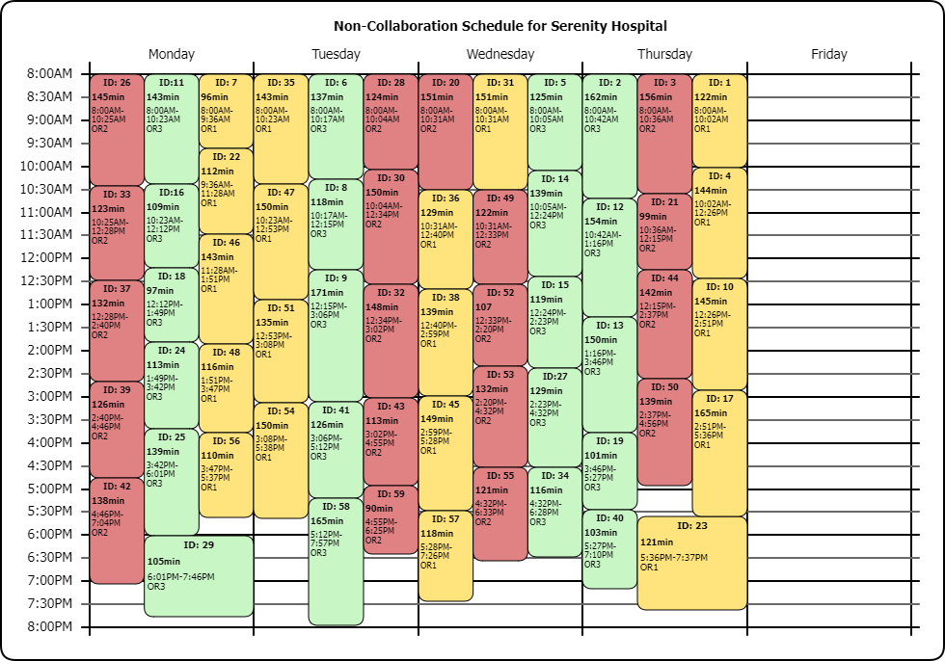

Firefly:

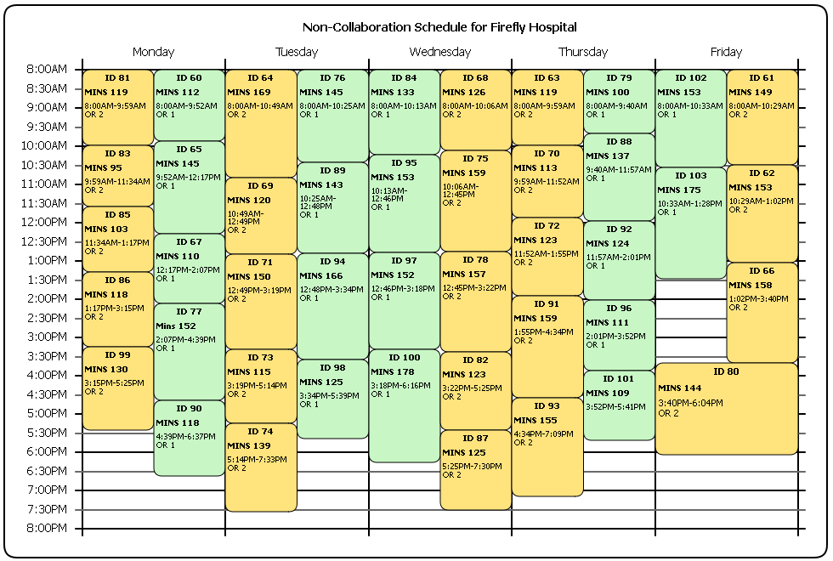

Hands of Blue:

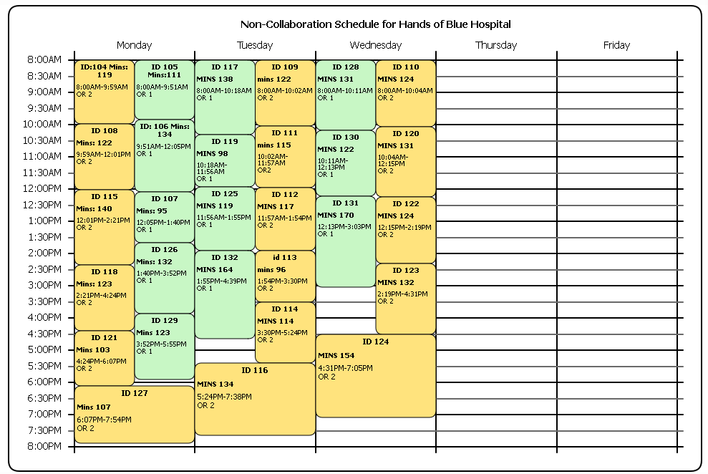

**Appendix B. Collaborative Schedule Visualization**

Serenity:

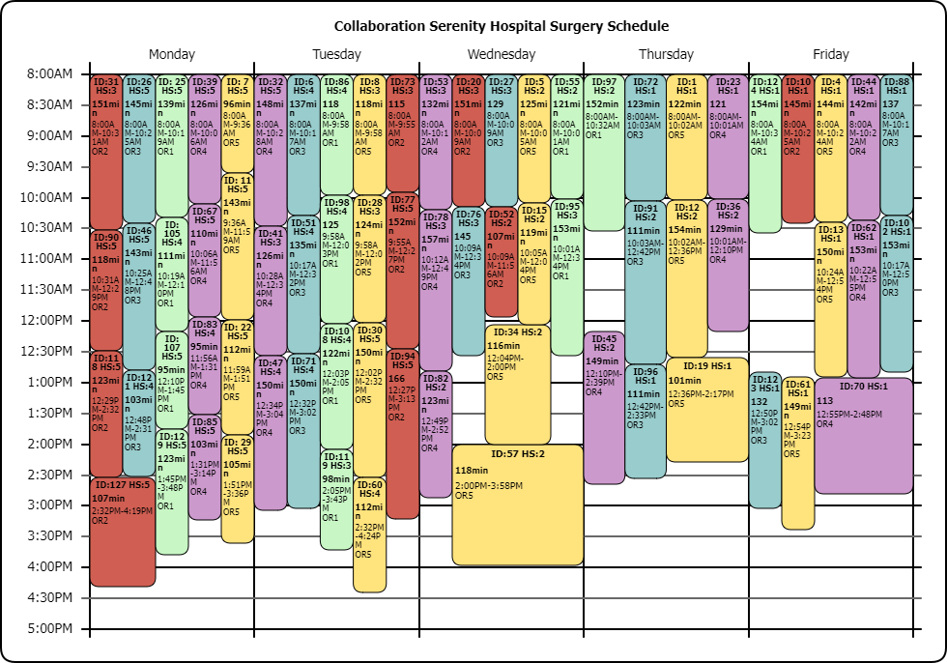

Firefly:

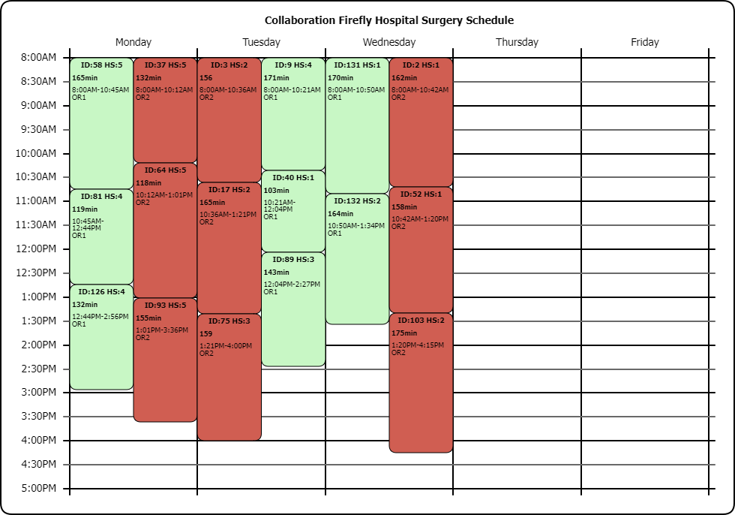

Hands Of Blue:

